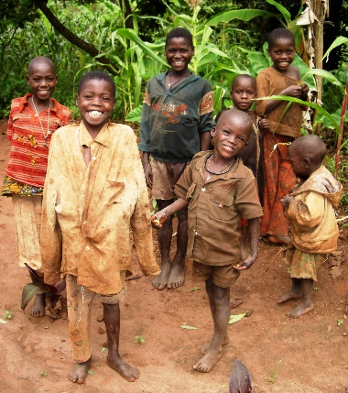

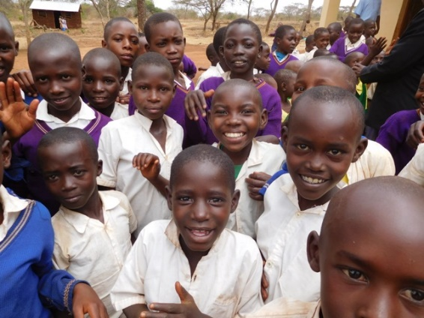

Tumaini Fund Canada

CHILD or FAMILY SPONSORSHIP

Information from Dr. Susan Wilson and in her own words…

“It is a wonderful thing – it changes children’s lives forever….if food runs out, they can buy some more; when their shoes wear out, they can buy some more.”

A new Sponsor will receive the following information:-

- Photograph of the child
- Name of the child or children
- Village
- Family background

Sponsorship provides to each child:-

- Food, clothing, school supplies, health support and upgraded housing under the care and guidance of local Tumaini Parish Workers and area Social Workers.

Cost of Sponsorship:-

- For just $100 per year, per child (less than 28 cents a day), we can change a child’s life from abject poverty to life with good health, an education and hope for future employment and self support.

- Specially appreciated are sponsorships of 2 or more children in one family.

Future Cloud Information:-

In Dr. Wilson’s words: “Tumaini is changing to a Microsoft Dynamics Database – there is some way to go, but I hope that it will be up-to-date in Tanzania very shortly….”

To Sponsor a Child or Family:-

Please Email : info@tumainicanada.org Attn: Child Sponsorship Coordinator
Or Mail to: Tumaini Fund Canada, 2341 Balsam Crescent, Nanoose Bay. BC V9P 9G2

Thank You for bringing Help and Hope through Tumaini Sponsorship

