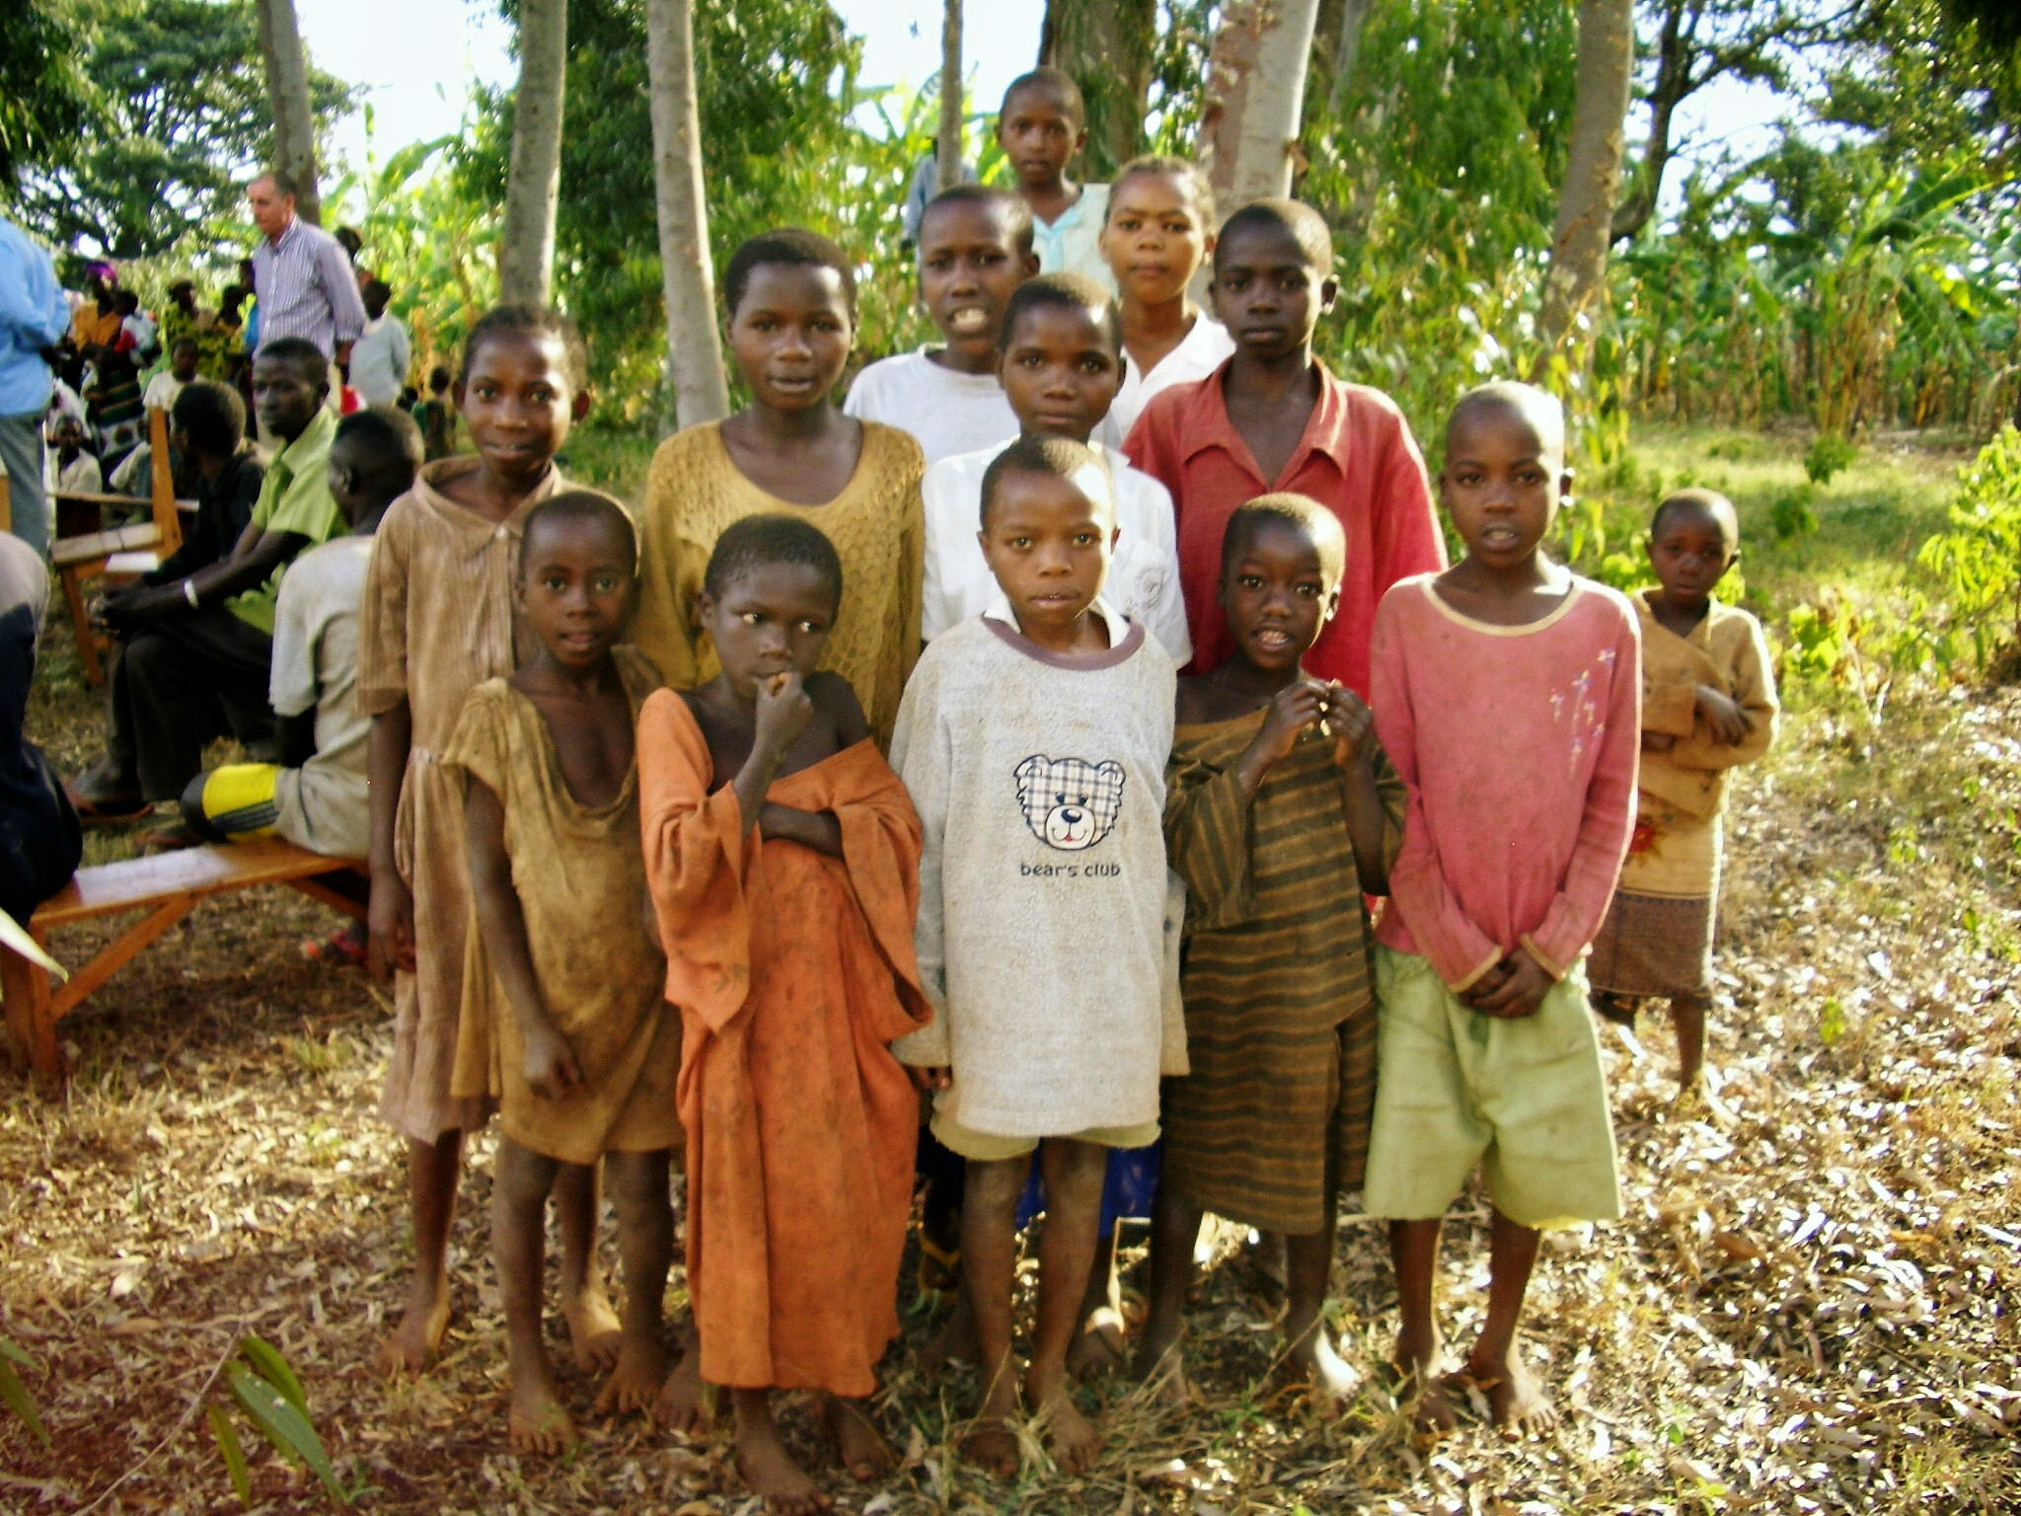

TUMAINI FUND CANADA (TFC) UPDATE: SUMMER 2018

BACKGROUND:
Since the introduction of Tumaini Fund to Vancouver Island in 2010, there has been growing support in Canada for this small but vital charity, working in Kagera, one of the poorest areas of Tanzania - one of the 10 poorest countries in the world.

Tumaini was founded in 2003 by Dr. Susan Wilson in Guernsey in the British Channel Islands. It has grown to support over 25,000 AIDs orphans, widows, and poor families by providing food, clothing, housing, clean water and access to schools and education for a better future. Approximately 6,000 Tumaini children are now in secondary school; many orphans train in Tumaini Tailoring and Carpentry Vocational Schools; 160 will be attending 2-year college programs in teaching, accountancy, administration, social work, agriculture, laboratory work, tourism, community development.
Adult education is expanding home businesses so families can improve their income and escape subsistence farming.

However, every year funds have to be raised to support this commitment, with many thousands of AIDs orphans and families still desperately needing help. Every child must have a school uniform in order to attend school. Tumaini is now a registered charity around the world in Guernsey, England, Scotland, USA, New Zealand, and Canada. In 2013 Tumaini Fund Canada became a registered Canadian charity with its head office based in Nanoose Bay, BC. Volunteers meet monthly in St. Mary's Anglican Church hall to sew, knit and crochet clothing, blankets and personal care kits, so urgently needed by our Tumaini children, and schoolgirls in Kagera. Tumaini Crafters have been immeasurably rewarded when they see their dresses, pants, sweaters and blankets in photos actually being worn by a child in faraway Africa and when they see a school girl carrying a drawstring bag with the Personal Care Kit which enables her to attend school full time.

NEWS & SUPPORT:
TFC holds regular fund raisers, such as Strawberry Teas and local bottle drives. Generous Canadians personally donate funds for Education, Housing, Water, Solar Lamps, Goats and Bicycles. Many also make the personal gift of Child Sponsorship, which is especially welcomed by Tumaini. The funds are wire transferred to our bank account in Kagera to be spent as designated by TFC. 100% of all donations for the orphans goes to Kagera.

In 2014 TFC received the gift of a 40' container and passage to Tanzania from ICROSS Canada. The container was packed with gifted humanitarian aid by Compassionate Resource Warehouse in Victoria, and after an eventful ocean voyage and overland transport, it arrived safely in Kagera. In 2011, 2016 and 2018 pallets were packed in Nanoose Bay with Crafters’ beautifully made blankets, clothing and toys. The pallets were sent by courier to Vancouver, onward by train to Montreal and then loaded onto a vessel for the long sea voyage either directly to Dar es Salaam, Tanzania, or more recently to Guernsey to be included in the next container to Dar es Salaam. After customs clearance and a long overland journey, this humanitarian aid is always so welcomed in Kagera.

In April 2017, TFC welcomed Alex Nyamkara to Canada and Nanoose Bay. Alex was an orphan supported by Tumaini through Secondary School and College, and he is now the Coordinator of Tumaini's head office in Ngara, Kagera.

In June 2018 the inspiring founder and CEO of Tumaini, Dr. Susan Wilson, will be with us in Nanoose Bay to meet our Crafters, attend various groups, and help us celebrate at our Strawberry Tea on June 23 at St. Mary’s Church.

THE TUMAINI FUND CANADA IS INDEBTED TO:
Dr. Susan Wilson, MBE: for her amazing leadership, & unfailing faith in what can be achieved if we all do our bit.
St. Mary’s Anglican Church, Nanoose Bay: for steadfast support since 2010 and the use of St. Mary’s hall and facilities. Blake, Cassels & Graydon LLP: for their pro bono work, valuable advice and ongoing guidance.
Mark McGorman: for his pro bono work as our Public Accountant, and ongoing financial advice.
Tumaini’s Canadian Volunteers: for continuing enthusiasm & support for all our fund raising activities.

Please visit our Website www.tumainicanada.org Charity Registration No 84352 7938 RR0001

